UNIVERSITY OF RWANDA
COLLEGE OF SCIENCE AND TECHNOLOGY
SCHOOL OF ICT
COMPUTER AND SOFTWARE ENGINEERING DEPARTMENT
GIKONDO CAMPUS
MODULE CODE/TITLE: WEB DESIGN
PROJECT TECHNICAL REPORT – WEB TECHNOLOGY
TECHNICAL ASSESSMENT 2025–2026
Project Title: KIDS LEARNING HUB
A Safe and Organized Online Learning Platform for Children
Prepared by: NAMBAJIMANA Gratien
Registration Number: 225031064
GitHub Repository: https://github.com/Gratien-Nambajimana/Kid-learning-Hub
Live Demo: https://gratien-nambajimana.github.io/Kid-learning-Hub/

Table of Contents
Table of Contents 2
Table of Figures 4
List of Abbreviations 5
Chapter 1. Introduction 6
1.1. Historical Background of the Case Study 6
1.2. Problem Statement 6
1.3. Objectives of the Project 6
1.4. Expected Outcomes 6
1.5. Project Rationale (Importance to the Community) 7
Chapter 2. System Analysis and Design 7
2.1. System Analysis 7
2.1.1. Intended Users of the Project 7
2.1.2. Intended System Partners 7
2.2. System Design 7
1. High-Level Architecture 7
2. UI Design (Sketch of the UI Module) and Flowcharts 8
3. Database Design with ERD and Relationships 9
Entities and Attributes (as designed) 11
USER 11
ADMIN 11
CATEGORY 11
COURSE 11
REGISTRATION 11
ANNOUNCEMENT 11
Relationship 12
Chapter 3. Implementation 12
3.1. Introduction 12
3.2. Screens with Screenshots and Discussion 12
3.2.1. Home Page 12
3.2.2. Courses Page 12
3.2.3. Registration Page 13
3.2.4. Login Page 14
3.2.5. Admin Dashboard 15
Chapter 4. Conclusion and Recommendation 17
State of the Implemented System 17
Recommendations 17
Appendix 18

Table of Figures

Figure 1: High-level architecture of Kids Learning Hub ......................................................................7
Figure 2: UI flowchart / site map of the main pages of the platform .................................................8
Figure 3: Entity Relationship Diagram of the Kids Learning Hub database (Chen notation, as designed) .............................................................................................................................................................. 9
Figure 4: Home page of Kids Learning Hub ..........................................................................................12
Figure 5: Courses page showing categorized learning videos ..............................................................12
Figure 6: User registration form ..........................................................................................................13
Figure 7: User and Admin login forms .................................................................................................14
Figure 8: Administrator dashboard with usage statistics and management tools ..............................15

List of Abbreviations
- UI – User Interface
- UX – User Experience
- ERD – Entity Relationship Diagram
- HTML – HyperText Markup Language
- CSS – Cascading Style Sheets
- JS – JavaScript
- DB – Database
- UR – University of Rwanda

Chapter 1. Introduction

1.1. Historical Background of the Case Study
Children today increasingly turn to the internet, and particularly to video-sharing platforms such as YouTube, to support their early learning of the alphabet, numbers, colors, and other foundational subjects. While these platforms host a wealth of genuinely educational content, they are built around open recommendation systems designed to maximize watch time rather than protect young viewers. As a result, a child who opens a learning video is frequently only a click away from unrelated, distracting, or age-inappropriate content, and has no dedicated space designed specifically around structured, age-appropriate learning.
Kids Learning Hub was conceived as a response to this gap: a small, focused web platform where children can watch organized educational videos — grouped into clear categories such as Alphabet, Numbers, Colors, and Science — without the noise, advertising, and unrelated recommendations that surround content on general-purpose video platforms.

1.2. Problem Statement
Parents and guardians who want their children to learn independently online currently have limited safe options. Relying on YouTube or similar platforms for children's education exposes them to:
- Unrelated and sometimes inappropriate content surfaced through autoplay and recommendations.
- A lack of structure — content is not organized by learning category or difficulty level.
- No mechanism for a parent to track what a child is watching or learning.
- Advertisements that interrupt the learning experience and can be distracting or misleading for young children.
There is therefore a need for a dedicated, distraction-free web platform that organizes children's educational videos by category, restricts content to what is relevant, and gives parents visibility and control over their child's learning.

1.3. Objectives of the Project
The general objective of this project is to design and develop a safe, organized, web-based learning platform for children. The specific objectives are to:
- Design a simple, child-friendly user interface for browsing and watching educational videos.
- Organize learning content into clear categories (Alphabet, Numbers, Colors, Science, Stories, and more).
- Implement a registration and login system so parents can create accounts and select a learning category for their child.
- Provide an administrator panel for managing users, uploading videos, organizing categories, and posting announcements.
- Eliminate distractions such as unrelated recommendations and third-party advertising from the learning experience.

1.4. Expected Outcomes
By the end of this project, the following outcomes are expected:
- A functional website with Home, Courses, Register, Login, and Admin pages.
- A working course catalog where videos are grouped by category and displayed with titles and short descriptions.
- A registration workflow that captures the parent's details, the child's age, and the preferred learning category.
- An administrator dashboard capable of tracking total users, total videos, categories, and messages, and of uploading new learning content.
- A deployed, publicly accessible version of the platform hosted on GitHub Pages.

1.5. Project Rationale (Importance to the Community)
Kids Learning Hub is relevant to parents, teachers, and young learners in the community because it offers a controlled alternative to open video platforms. Parents gain peace of mind knowing their children are watching only vetted, organized educational content. Teachers and early-childhood educators can point pupils to a single, structured resource rather than an unpredictable open platform. For children, a simplified interface focused only on learning content reduces distraction and supports more consistent, focused study habits — particularly valuable in households and communities where guided, in-person tutoring is not always available.

Chapter 2. System Analysis and Design

2.1. System Analysis

2.1.1. Intended Users of the Project
- Children (approximately ages 3–10) — the primary consumers of the learning videos, using the Home and Courses pages.
- Parents/Guardians — register accounts on behalf of their children, choose a learning category, and can monitor learning progress.
- Administrator — manages the platform: uploads videos, creates categories, reviews registered users, and posts announcements through the Admin panel.

2.1.2. Intended System Partners
- Early-childhood educators and schools who could recommend the platform as a supplementary learning tool.
- Content creators/educators who could contribute vetted educational videos to expand the course catalog.
- Parents' associations or community learning centers that could promote safe, distraction-free study tools for children.

2.2. System Design

1. High-Level Architecture
Kids Learning Hub follows a simple client-side web architecture typical of an early-stage web project. The frontend is built with HTML, CSS, and JavaScript and organized into five main pages: index.html (Home), courses.html (Courses), Register.html (Registration), login.html (Login), and admin.html (Admin dashboard). The Admin page currently uses static/mock data (illustrative user records and video counts) to demonstrate the intended dashboard layout and management workflow; the next development phase is to connect these pages to a real backend service and database so that registrations, video uploads, and dashboard statistics are stored and retrieved dynamically rather than hard-coded.
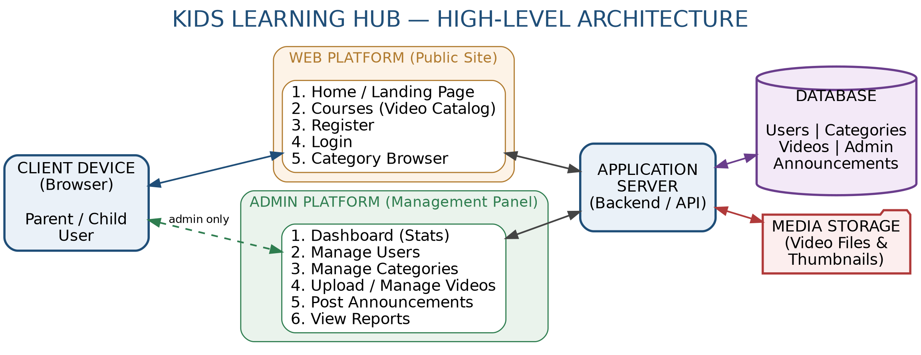
Figure 1: High-level architecture of Kids Learning Hub

2. UI Design (Sketch of the UI Module) and Flowcharts
The website is organized around five core screens, linked through a consistent top navigation bar:
- Home — introduces the platform and lists the available learning categories (Alphabet, Numbers, Colors, Science).
- Courses — displays the video catalog grouped by category, each entry with a title and short description (e.g., "ABC Alphabet Song", "Counting Numbers", "Learning Colors").
- Register — a form collecting Full Name, Email, Password, Child Age, Learning Category, and optional Feedback.
- Login — separate login forms for regular users (Email/Password) and for the Administrator (Admin Username/Password).
- Admin — a dashboard showing total users, total videos, categories, and new messages, a table of registered users, a video upload form, and tools to add categories, delete videos, and post announcements.
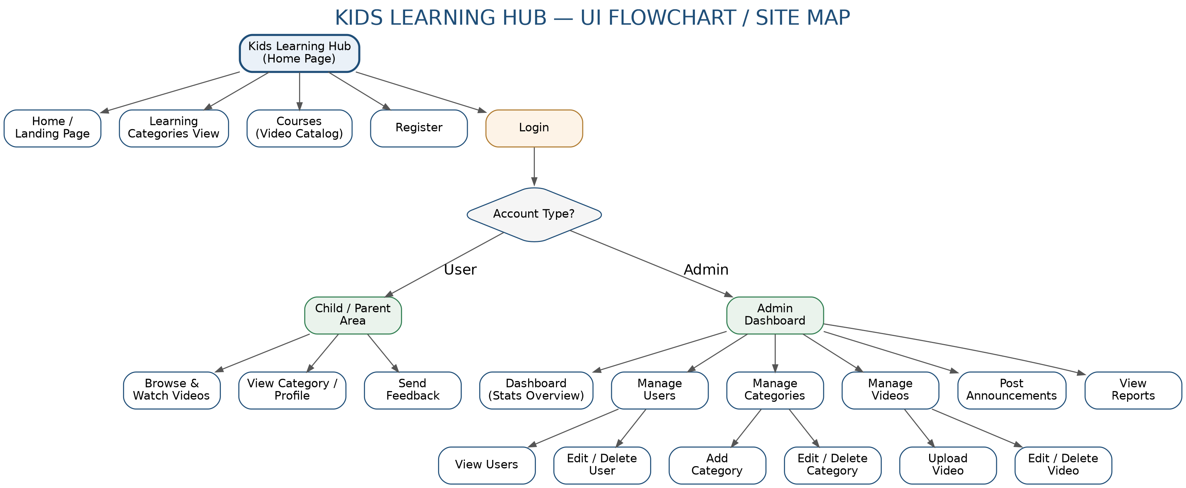
Figure 2: UI flowchart / site map of the main pages of the platform

3. Database Design with ERD and Relationships
Although the current deployed version uses static/mock data for demonstration, the platform is designed around the following logical data model, which the backend implementation will use:
Entity | Key Attributes
User | user_id (PK), full_name, email, password, child_age, category_id (FK)
Category | category_id (PK), name, description, level
Video | video_id (PK), title, description, file_url, thumbnail_url, category_id (FK)
Admin | admin_id (PK), username, password
Announcement | announcement_id (PK), title, message, admin_id (FK), date_posted
Relationships:
- One User (parent/child account) belongs to one Category (learning preference) — a one-to-many relationship from Category to User.
- One Category has many Videos — a one-to-many relationship from Category to Video.
- One Admin manages many Videos and many Announcements.
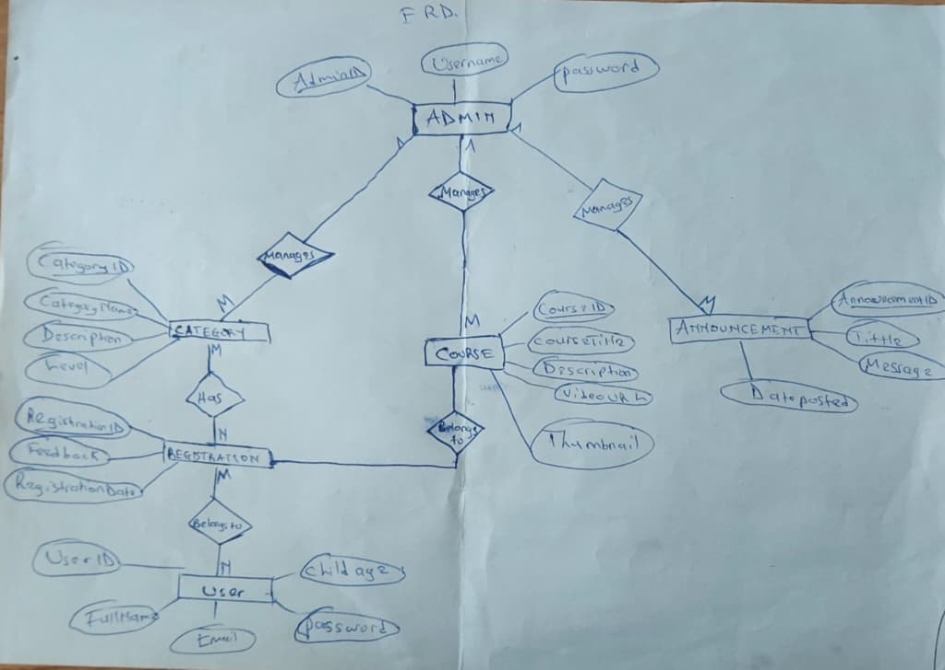
Figure 3: Entity Relationship Diagram of the Kids Learning Hub database (Chen notation, as designed)

Entities and Attributes (as designed)
Reg No: 225031064 | Department: Computer Engineering | Web Design Work, 9th July 2026

USER
- UserID (PK)
- FullName
- Email
- Password
- ChildAge

ADMIN
- AdminID (PK)
- Username
- Password

CATEGORY
- CategoryID (PK)
- CategoryName
- Description
- Level

COURSE
- CourseID (PK)
- CourseTitle
- Description
- VideoURL
- Thumbnail
- CategoryID (FK)
- AdminID (FK)

REGISTRATION
- RegistrationID (PK)
- UserID (FK)
- CategoryID (FK)
- Feedback
- RegistrationDate

ANNOUNCEMENT
- AnnouncementID (PK)
- Title
- Message
- DatePosted
- AdminID (FK)

Relationship
- User (M) → (N) Registration
- User (M) → (N) Category
- Admin (1) → (M) Category
- Admin (1) → (M) Announcement
- Admin (1) → (M) Courses
- Category (M) → (N) Registration

Chapter 3. Implementation

3.1. Introduction
This chapter presents the implemented screens of Kids Learning Hub as deployed on GitHub Pages, with a short discussion of each screen's purpose, layout, and functionality. Screenshots should be inserted in place of each placeholder box below.

3.2. Screens with Screenshots and Discussion

3.2.1. Home Page
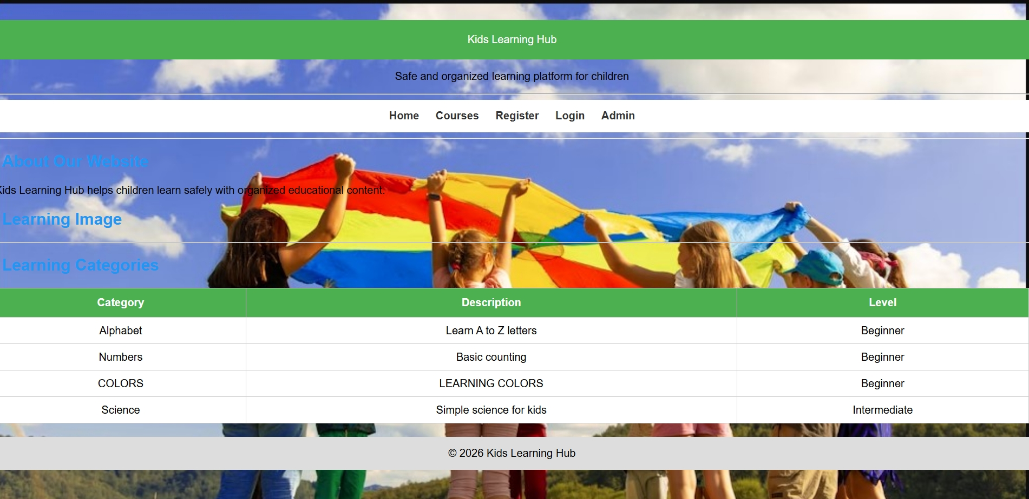
Figure 4: Home page of Kids Learning Hub
The Home page is the platform's entry point. It presents the platform name and tagline ("Safe and organized learning platform for children"), a short "About Our Website" section, and a table of the available Learning Categories — Alphabet, Numbers, Colors, and Science — each with a short description and difficulty level (Beginner or Intermediate). A top navigation bar gives quick access to Home, Courses, Register, Login, and Admin. This page's main purpose is to orient a parent or child immediately to what the platform offers and to funnel them toward registration or the course catalog, without any external links, advertising, or unrelated content competing for attention.

3.2.2. Courses Page
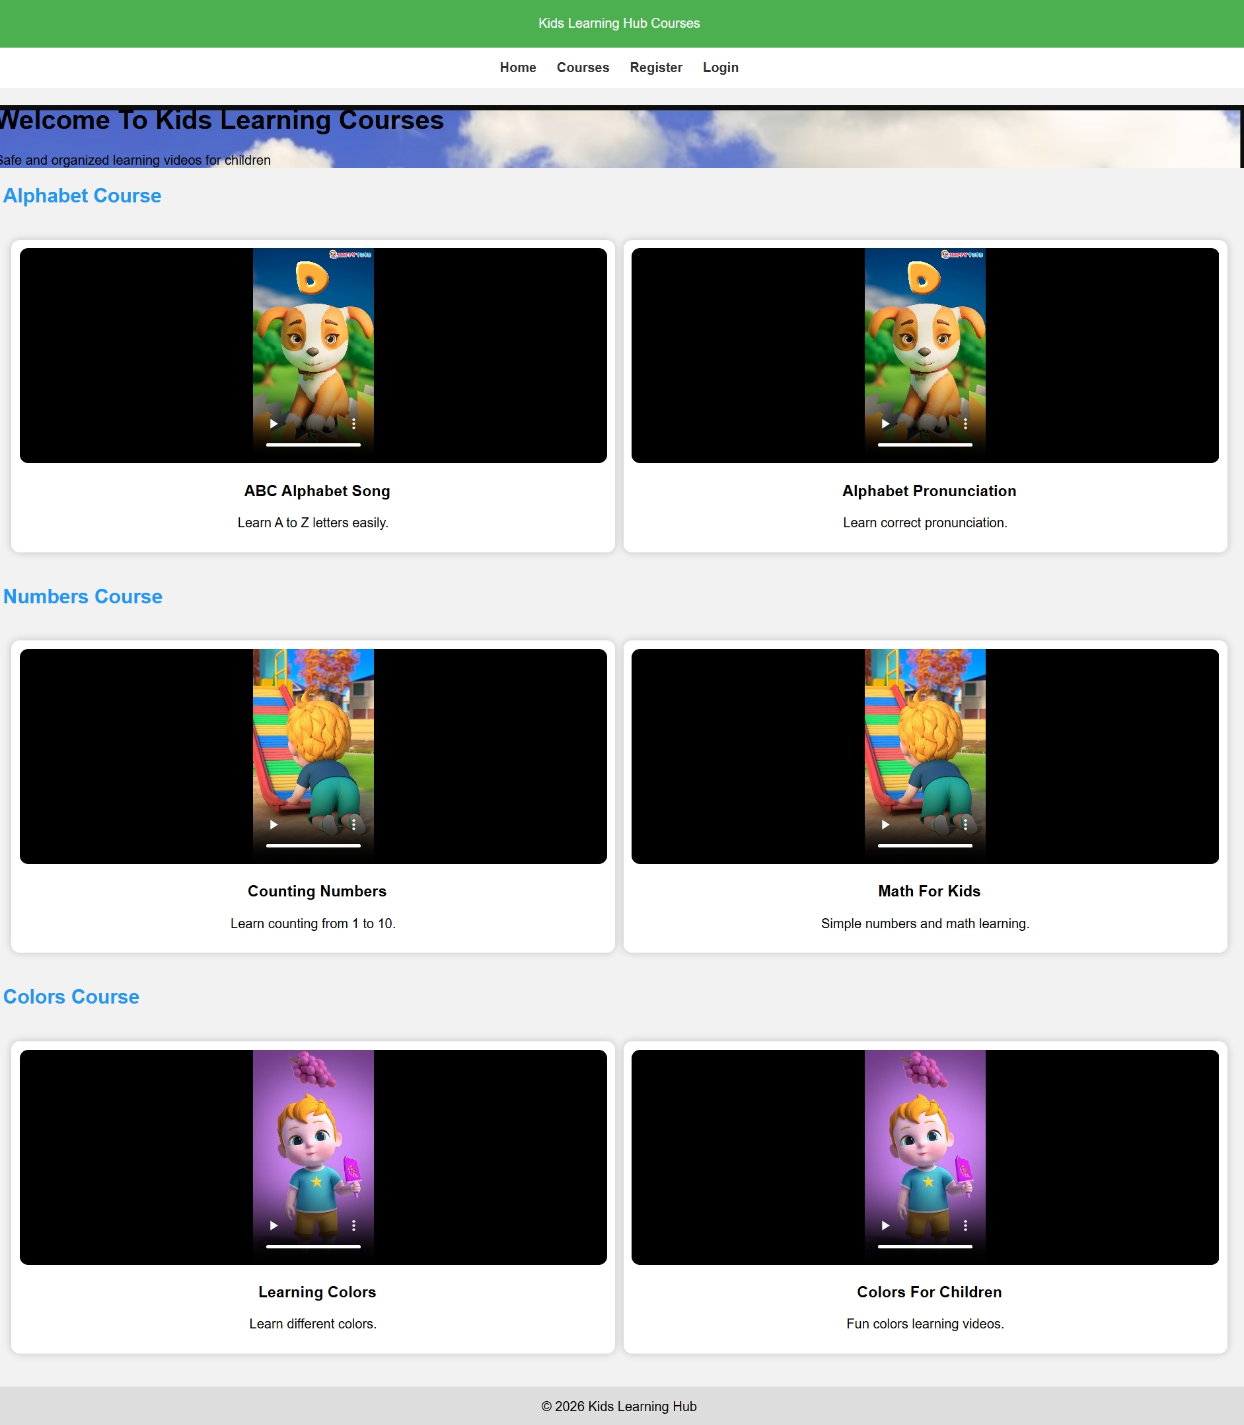
Figure 5: Courses page showing categorized learning videos
The Courses page lists the learning videos grouped under their respective categories. Under "Alphabet Course", videos such as the ABC Alphabet Song and an Alphabet Pronunciation video are listed with short descriptions. The Numbers Course groups Counting Numbers and Math for Kids videos, and the Colors Course groups Learning Colors and Colors for Children videos. Each video entry has a clear title and one-line description so a parent or child can quickly identify relevant content. Because videos are strictly organized by category and no external or unrelated links are shown, the page directly addresses the core problem of distraction that this project set out to solve.

3.2.3. Registration Page
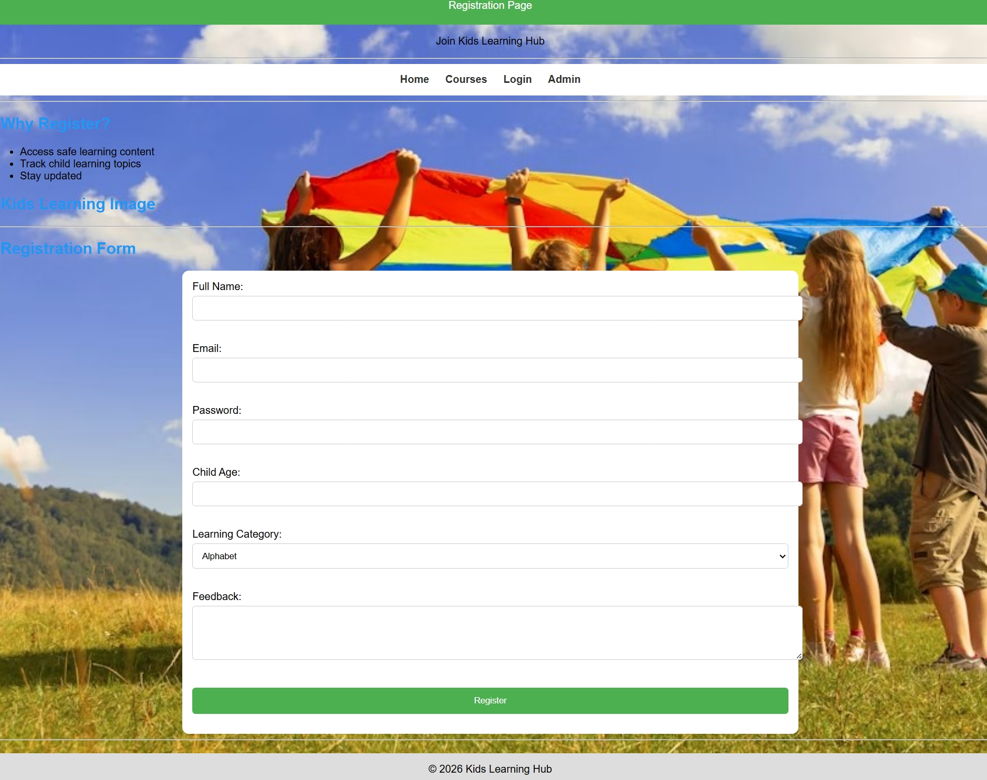
Figure 6: User registration form
The Registration page allows a parent to create an account on behalf of their child. The form captures Full Name, Email, Password, Child Age, and preferred Learning Category (Alphabet, Numbers, Colors, Stories, or Funny Songs), plus an optional Feedback field. A short "Why Register?" section explains the benefit of registering — access to safe content, the ability to track what topics the child is learning, and platform updates. This page is the main entry into the personalized part of the platform and is designed to be short enough that a parent can complete it in under a minute.

3.2.4. Login Page
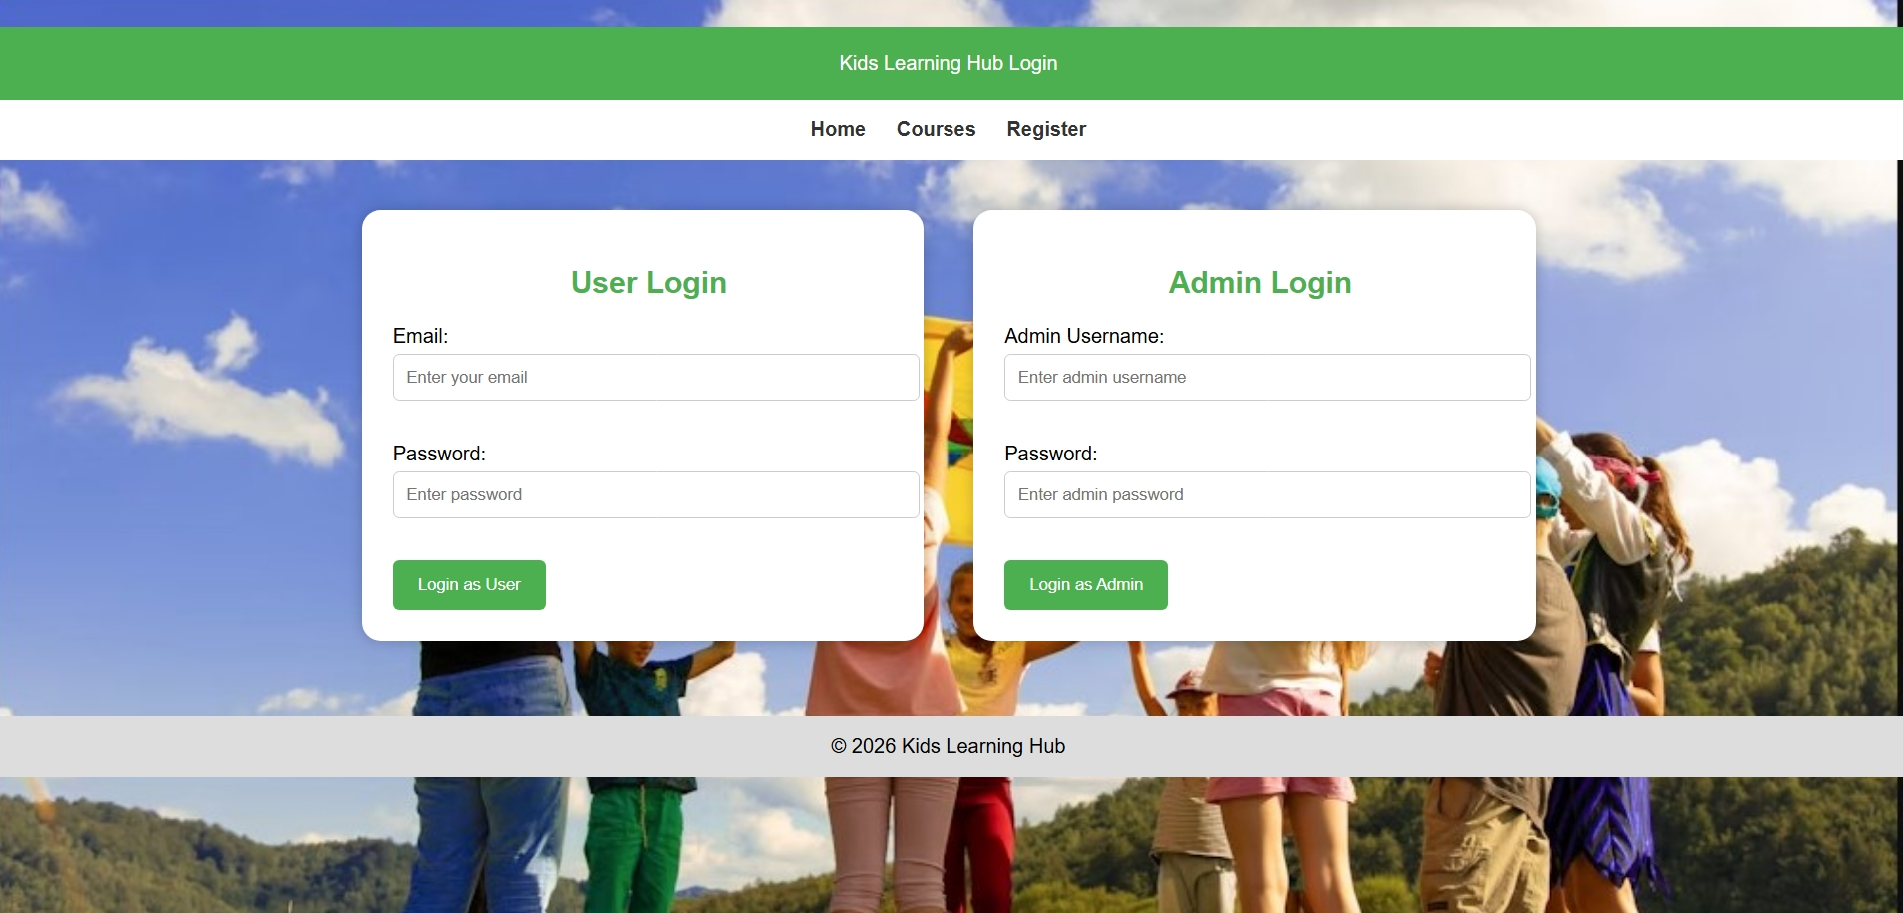
Figure 7: User and Admin login forms
The Login page provides two distinct forms on a single screen: a User Login (Email and Password) for parents/children accessing the course catalog, and an Admin Login (Admin Username and Password) for the platform administrator. Separating these two login paths on one page keeps the interface simple while still enforcing a clear distinction between regular users and administrative access to the management dashboard.

3.2.5. Admin Dashboard
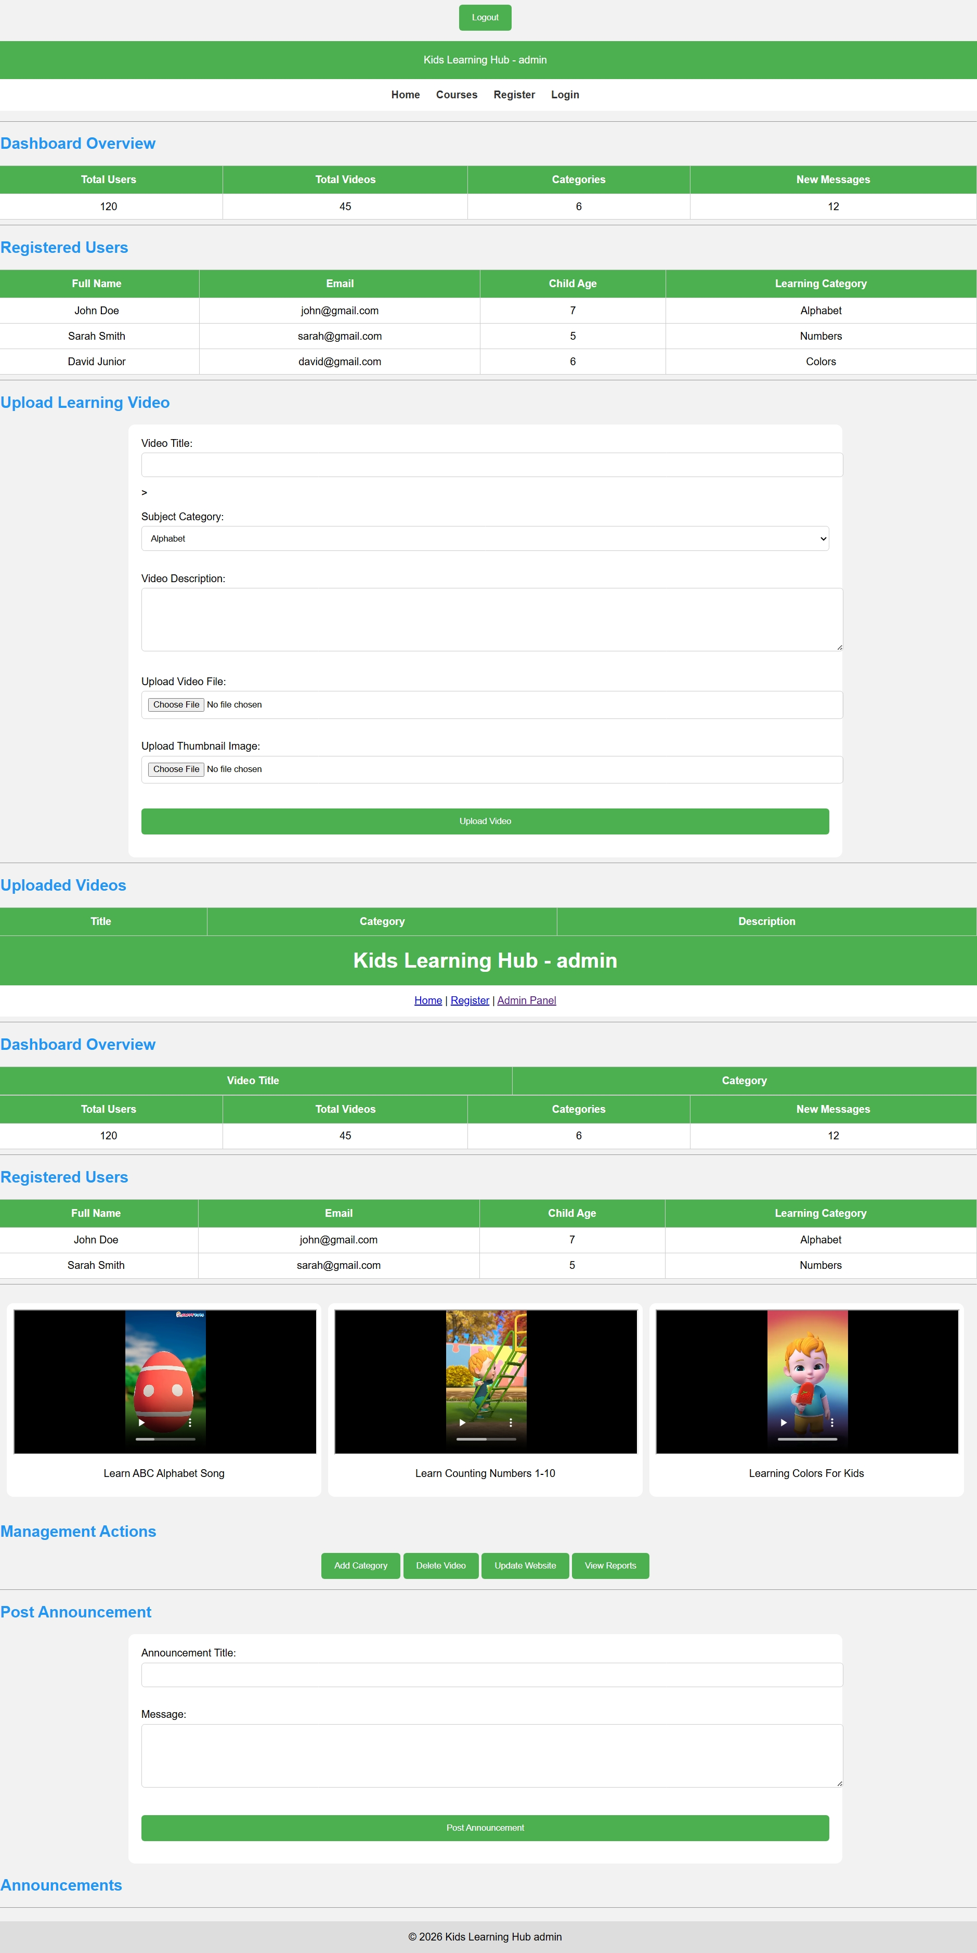
Figure 8: Administrator dashboard with usage statistics and management tools
The Admin dashboard is the management centre of the platform. It opens with a Dashboard Overview showing key counters — Total Users, Total Videos, Categories, and New Messages — giving the administrator an at-a-glance view of platform activity. Below this, a Registered Users table lists each account's full name, email, child's age, and chosen learning category. An Upload Learning Video form lets the administrator add new content by specifying a video title, subject category, description, video file, and thumbnail image. Further Management Actions allow the administrator to add categories, delete videos, update the website, and view reports, and a Post Announcement section lets the administrator broadcast messages to users. Together, these tools give the administrator full control over the content children see on the platform.

Chapter 4. Conclusion and Recommendation

State of the Implemented System
At the current stage, Kids Learning Hub successfully implements its core frontend objectives: a clear, child-friendly Home page, a categorized Courses catalog, a Registration form capturing parent and child details, a dual User/Admin Login page, and an Admin dashboard demonstrating the intended management workflow (user tracking, video upload, category management, and announcements). Based on the objectives defined in Chapter 1, an estimated 70–80% of the planned functionality has been achieved at the interface and structural level.
The main outstanding work is backend integration: the Admin dashboard currently displays illustrative/mock data (e.g., static counts and sample registered users) rather than data persisted from real registrations, and the video entries reference local file paths rather than a hosted video/database service. Connecting the platform to a real backend and database, and hosting the actual video files, remains the primary next step before the system can be used with real users.

Recommendations
To the lecturer, regarding technicalities:
- Guidance on selecting and integrating a lightweight backend (e.g., Node.js/Express with a database such as MongoDB or MySQL) would help move the project from a static demonstration to a functioning system.
To the school, regarding time constraints:
- Additional project time or a follow-up module would allow full backend implementation, authentication security, and user testing with real parents and children.
To the partners (schools, educators):
- Early feedback from educators on the category structure and video selection would help ensure the content matches real curricula and age groups.
To the user, regarding training:
- Once deployed with real data, a short onboarding guide should be provided to parents explaining registration, category selection, and how to supervise their child's account.
To the beneficiaries (children and parents):
- Parents are encouraged to sit with younger children during initial use to help them navigate the categories until they are comfortable using the platform independently.

Appendix
GitHub Repository (source code): https://github.com/Gratien-Nambajimana/Kid-learning-Hub
Live Deployed Site: https://gratien-nambajimana.github.io/Kid-learning-Hub/

